CONSISTENCY CHECK BETWEEN ANALYSIS INPUT/OUTPUT-FOM
- DMT –

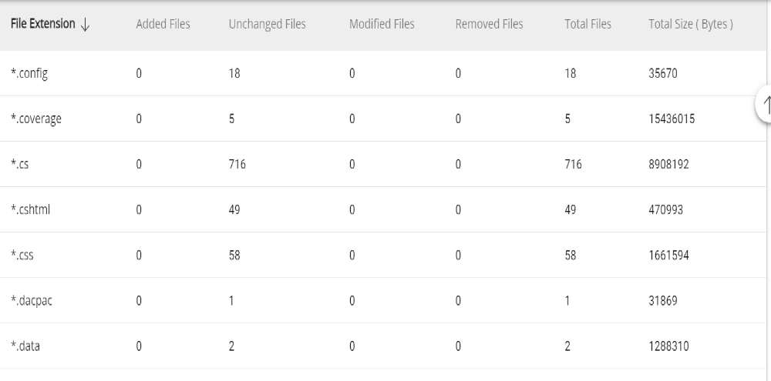
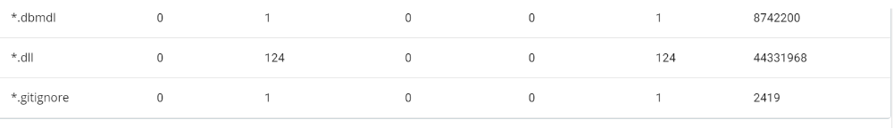
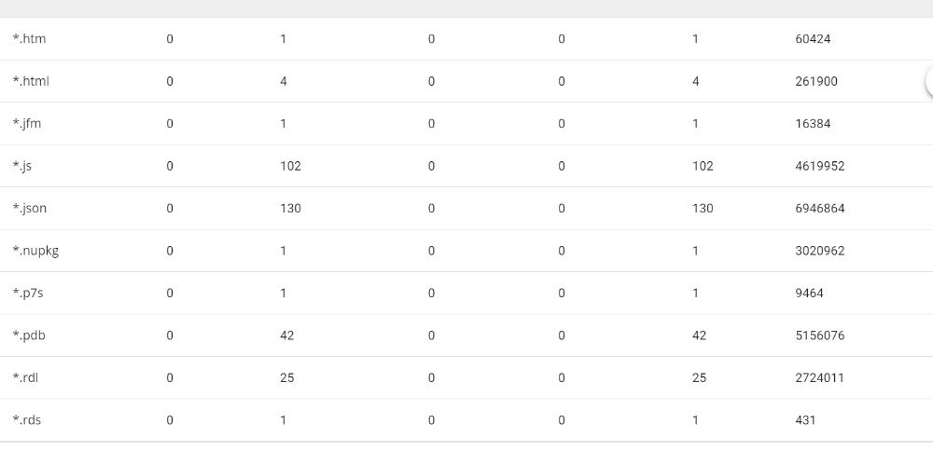
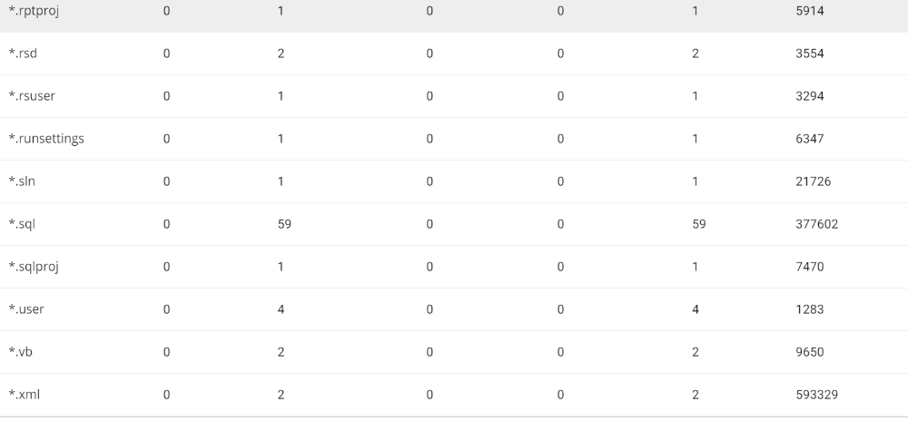

- Deploy –
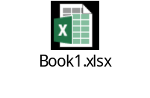
- Postgres –
